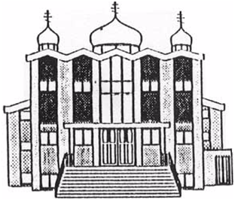Carol lynn

M E M B E R S H I P A P P L I C A T I O N

**********************************

**I, the undersigned, wish to become a member of St. Michael’s Ukrainian Orthodox Parish in Edmonton, Alberta, and hereby agree to adhere to the teaching, constitution and by-laws of the Ukrainian Orthodox Church of Canada, the by-laws of this Parish, and agree to fulfill all membership obligations of the parish.**

**With this application, please include the following persons:**

***Family (Surname) Name: ­­­­­­­____________________________________________________***

***Address: _________________________________________________________________________***

***__________________________________________________Postal Code: __________________***

***Telephone: ______________________ Email: _______________________________________***

***_***

***(First Name) (Age – Day/Month/Year)***

***Mr. ________________________________________________________________________________***

***Mrs. _______________________________________________________________________________***

***Miss: _____________________________________________________________________________***

***Children: ________________________________________________________________________***

***__________________________________________________________________________***

***___________________________________________________________________________***

***Marriage Date: ________________________________________________________________***

***Applicant’s Signature________________________________________________________***

***Date: ­­­­­­­­­­­­­­­­­­­­­______________________________________***

**Ukrainian Orthodox Church of St. Michael the Archangel**

**12104 – 129 Ave**

**Edmonton, Alberta**

**T5L 3J1**

**For further information about membership, please email your questions to vmlakusta@ gmail.com**

**or**

[**stmichael@shaw.ca**](mailto:stmichael@shaw.ca)

**or call the Parish President @ 780-476-3646**

**or the Parish Priest**

**@ 204-333-7810**

**Drop off completed forms at the Church Office on Sundays or drop off in the Church mailbox (on the south side).**

**Or join us during worship services on Sunday.**

***See our Parish Website for service dates.***

***uocc-stmichael.ca***

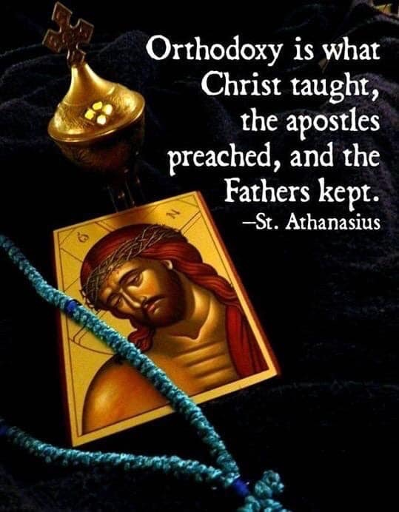

OPPICE USE ONLY

File Number ______