**March 10, 2024**

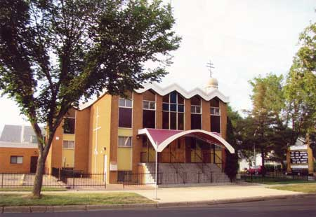

**Parish Bulletin Supplement**

**Announcements**

Great Fast

March 18th – May 5th

Edmonton Deanery Lenten Services

**Parish Holy Week Services**

***Palm Sunday, April 28th***

***“Entrance of our Lord into Jerusalem”***

***Liturgy, 10 a.m.***

***Blessing of Willows***

***Holy Thursday, May 2nd***

***Reading of Passion Gospels***

***6 p.m.***

***Holy Friday, May 3rd***

***Procession of the Holy Epitphios***

***5:30 p.m.***

***Holy Saturday, May 4th***

***Bringing of the Holy Epitphios into the Sanctuary***

***Blessing of Easter Baskets***

***3 p.m.***

***EASTER SUNDAY (PASCHA)***

***“Bright Resurrection of Christ”***

***May 5th, 8 a.m.***

***Paschal Liturgy & Blessing of***

***Easter Baskets***

***Christ Is Risen!***

***GRAVESIDE SERVICES***

***will be held between***

***May 12 – June 9.***

***Details TBA***

***Canon of St. Andrew of Crete***

***6:oo p.m.***

***Clean Monday, March 18th – St. Andrew Church***

***Clean Tuesday, March 19th – St. Elais Church***

***Clean Wednesday, March 20th – St. Michael’s Church***

***Clean Thursday, March 21st – St. Anthony’s Church***

***Clean Friday, March 22nd – Liturgy of Pre-Sanctified Gifts***

***…St. John’s Cathedral, 9:30 a.m. *Confession & Communion”***

***Holy Unction Service***

***Great & Holy Wednesday***

***May 1st, 6 p.m.***

***will be celebrated this year at***

***St. Michael’s Church.***

***The expressed purpose of the Sacrament of Holy Unction is healing and forgiveness.***

First Sunday of Great Lent – “Triumph of Orthodoxy” Vespers

Saturday March 23,

6 p.m.

St. John’s Cathedral

**Passia Lenten Services**

**6:00 P.M.**

**2nd Sunday of Great Lent, March 31 @ St. Elais**

**3rd Sunday of Great Lent, April 7th @ St. Anthony’s**

**4th Sunday of Great Lent, April 14th @ St. Andrew’s**

**5th Sunday of Great Lent, April 21st @ St. Michael’s**

***Lenten Lunch & Orthodox Teaching will follow.***

**Rt. Rev. Protopresbyter Victor Lakusta**

**Res: 780-439-6289**

**Mobile/Text: 1-204-333-7810**

**Email: vmlakusta@gmail.com**